Document version: 2024-05-21

Declaration of Originality
Complete this form if/as directed by your unit coordinator, lecturer or the assignment specification.

Unit name/code | Computer Science Project 1 COMP6015 | Supervisor(s) | Tom Gedeon
I/We declare that:
- The above information is complete and accurate.
- The work I am/We are submitting is entirely my/our own, except where clearly indicated otherwise and correctly referenced.
- I/We have taken (and will continue to take) all reasonable steps to ensure my/our work is not accessible
to any other students who may gain unfair advantage from it.
- I/We have not previously submitted this work for any other unit, whether at Curtin University or elsewhere, or for prior attempts at this unit, except where clearly indicated otherwise.
I/We understand that:
- Plagiarism and collusion are dishonest, and unfair to all other students.
- Detection of plagiarism and collusion may be done manually or by using tools (such as Turnitin).
- If I/We plagiarise or collude, I/We risk failing the unit with a grade of ANN (“Result Annulled due to Academic Misconduct”), which will remain permanently on my academic record. I/We also risk termination from my/our course and other penalties.
- Even with correct referencing, my/our submission will only be marked according to what I/we have done myself/ourselves, specifically for this assessment. I/We cannot re-use the work of others, or my/our own previously submitted work, in order to fulfil the assessment requirements.
- It is my/our responsibility to ensure that the submission is complete, correct and not corrupted.

Date: ______06/04/2025_____________________________________

Surname | Given Name(s) | Student ID | Signature
Anshul | Patel | 21676628
Krina | Jogani | 21990577
Nirali | Patel | 22033415
Ruly | Wijaya | 21784408 | 
Qifeng | Bi | 21456998 | 
Urva | Patel | 21717051 | 


ECG Filter Feature to Preserve Privacy
Project Proposal COMP6015
Computer Science Project

Group Member | Enrolment No. | Master or Major
Anshul Patel | 21676628 | Master (Computer science)
Krina Jogani | 21990577 | Master (Computer science)
Nirali Patel | 22033415 | Master (Computer science)
Ruly wijaya | 21784408 | Master (Computer science)
Qifeng Bi | 21456998 | Master (Computer science)
Urva Patel | 21717051 | Master (Cyber security)

Table of Contents
Table of Contents
Individual contributions 4
Executive Summary / Abstract 5
Project Overview 5
Approach to Addressing the Challenge 5
Expected Outcomes and Impact 5
1. Introduction 6
1.1 Problem Statement 6
1.2 Aims 6
1.3 Scope 6
2. Background 6
2.1 ECG Feature Extraction for Medical and Biometric Applications 6
2.2 Challenges and Gaps in Literature 7
3. Innovation and Significance 7
3.1 Innovation 7
3.2 Significance and Impact 8
4. Methodology 8
4.1 Project Development Process 8
4.1.1 Data Preprocessing 8
4.1.2 Feature Extraction 8
4.1.3 Deep Learning Model Design 9
4.1.4 Signal Modification and Reconstruction 9
4.2 Tools and Technologies 9
4.2.1 Software Development Tools 9
4.2.2 Tech Stack 9
4.2.3 Development Environment 10
4.3 Evaluation Plan 10
4.3.1 Model Accuracy Evaluation 10
4.3.2 Metrics for Evaluation 10
4.4 Data Management Plan 10
4.4.1 Data Collection and Storage 10
4.4.2 Data Processing 10
4.4.3 Privacy Protection 10
4.5 Ethical Considerations 11
4.5.1 Data Security 11
4.5.2 Privacy Concerns 11
4.5.3 Non-maleficence 11
4.5.4 Bias in Data 11
5. Project Management 12
5.1 Timeline 12
5.2 Milestones 12
5.3 Risk Management Plan 12
5.4 Task and team Responsibilities 13
6. References 14
Appendix 16
A. Declaration of Originality 16

Individual Contributions:

Name | Role | Tasks
Anshul Patel | Team member
Krina Jogani | Team member
Nirali Patel | Team member
Ruly wijaya | Leader
Qifeng Bi | Team member
Urva Patel | Team member

Executive Summary / Abstract

Project Overview

The research project improves biometric authentication privacy through modifications made to Electrocardiogram (ECG) signals that either maintain important data features or eliminate information fully. The ECG waves provide medical and identity-related details that assist doctors with diagnosis and authorization processes. A policy concern exists regarding the storage of unmodified ECG data because it creates privacy vulnerabilities. The goal of this project involves building methods which let institutions including hospitals and banks keep essential ECG signal parts without either medical details or identity markers.

Approach to Addressing the Challenge

The project uses combination techniques between deep learning technology and signal processing approaches to handle ECG data filtering. The methodology includes:

Proposed Research Expansion Includes the Modification of Available EEG Anonymization Techniques to Handle ECG Signals.

The development of neural network programs served to transform ECG records through information removal of identification data and medical characteristics while maintaining essential signal characteristics.

The analysis of modified signals through machine learning classifiers serves to validate and classify information removal effectiveness through accuracy assessment.

The implementation will use software tools including Python as well as TensorFlow/PyTorch and MATLAB where the ECG datasets will be obtained from publicly shared repositories for both training and testing purposes.

Expected Outcomes and Impact

The system allows ECG-based authentication by removing health information since it respects privacy regulations.

The secure management of medical data becomes possible when hospitals store ECG records without including identity information thus minimizing privacy-related issues.

The collaborative work of AI algorithms and Signal Processing generates knowledge that advances deep learning techniques in the field of physiological signal analysis.

The future potential of related research consists of two main points: first it can expand to multiple biometric systems beyond ECG and secondly it can function as part of operational authentication systems such as secure ECG-based ATM security.

1. Introduction

Digital world and internet are rapidly grown over decades. Fast and convenient are major aspects to be considered. Facial recognition, fingerprint and iris scanning are conventional biometric technologies to verifying individuals’ identity. However, external biometrics are prune to privacy risks. Covert collection without consent is one of the security vulnerabilities (OVIC, 2019). Non-consensual photograph can be used to illegal verification. Recent studies are exploring internal biometrics for verifying identity.

Electrocardiogram (ECG) is a record of heart’s electrical activity as waveforms. ECG is one of the most valuable diagnostic tools to diagnose and monitor heart conditions (Lippincott Williams & Wilkins, 2008). Since ECG can show cardiac muscle activities over a certain timeframe and everyone’s ECG is unique because cardiac activity is impacted by age, gender, height, weight and also lifestyle (Hong, Shenda, Can Wang, and Zhaoji Fu, 2020). Based on this fact, ECG can be used to identify a person.

1.1 Problem Statement

Raw ECG data contain health and personal information. This project prevents raw data from being stored to avoid its misuse in compromising ECG identity verification. By removing private data from raw ECG data, ECG can only be used for diagnosing health issues.

1.2 Aims

The aim of this project is to filter ECG of identity/health information from a person’s ECG data. This is also aligned with Australian privacy law that restrict unauthorised collection or used of health information (Department of Health and Aged Care, 2012). The result of this project will help public to implement ECG biometric validation without violating the law or violation of health data privacy.

1.3 Scope

This project uses artificial intelligent such as Deep Learning Techniques to remove health information from ECG as adaptation of previous study “Disguising Personal Identity Information in EEG Signals” (Shiya Liu, 2025). To check if the adaptation works, this project uses an application of health issue detection.

2. Background

Electrocardiograms (ECGs) are increasingly utilised in both clinical diagnostics and biometric identification due to their inherent richness in physiological and identity-specific information. Traditionally, ECG signals are analysed to detect cardiovascular conditions such as arrhythmias, myocardial infarction, and other structural or electrical abnormalities. More recently, their unique waveform patterns—particularly in the QRS complex and T-wave morphology—have been leveraged in biometric authentication systems, making ECG a dual-use biometric modality.

2.1 ECG Feature Extraction for Medical and Biometric Applications
Medical analysis of ECGs typically involves extracting clinical features such as the QRS complex, ST segment, QT interval, and heart rate variability. These features are vital for diagnosing cardiovascular issues. At the same time, researchers have found that certain morphological and temporal ECG features are highly person-specific and can be effectively used for biometric authentication. Wang et al. (2007) demonstrated the viability of ECG signals as a biometric modality, focusing on the analysis of human ECG for identity recognition. Their findings show that ECGs provide not only reliable health data but also a unique physiological signature that can distinguish individuals with high accuracy. Odinaka et al. (2012) carried out a comparative analysis of different ECG biometric recognition methods. Their study assessed both fiducial and non-fiducial approaches, finding that ECG signals maintain considerable consistency across various recording sessions, making them a robust modality for biometric systems. Agrafioti, Hatzinakos, and Anderson (2012) explored another dimension of ECG signals—their potential to reflect emotional states. Their work illustrates how ECG morphology changes with emotional stimuli, further reinforcing the complexity and richness of ECG data, and hence the challenge in protecting its privacy when used in open or distributed systems.

2.2 Challenges and Gaps in Literature
Despite these advancements, a number of limitations persist in the current research landscape. One key issue is the absence of standardized methods for selectively extracting or filtering features that are strictly necessary for either diagnosis or authentication, without compromising privacy. Meltzer and Luengo (2025) provide a comprehensive survey of ECG-based biometric recognition methods and databases. They highlight the need for better frameworks to distinguish between identity-linked and health-critical features, especially in the context of data sharing and regulatory compliance. Pereira et al. (2023) further emphasize the variability introduced by different ECG acquisition methods, noting that hardware inconsistencies, signal noise, and body placement affect the accuracy of both biometric and clinical applications. Their systematic review underlines the necessity for harmonized data acquisition protocols and more robust, privacy-aware signal processing techniques.
Together, these studies underscore the critical need for a privacy-preserving approach to ECG feature extraction. As ECGs are increasingly used in wearable and remote health-monitoring technologies, there is growing urgency to develop methods that can differentiate between identity-revealing and medically relevant features. Doing so would not only help safeguard personal data but also facilitate the ethical use of ECG in both healthcare and biometric systems.

3. Innovation and Significance

3.1 Innovation
A novel method for protecting sensitive ECG data while maintaining crucial features for medical analysis is presented in the proposed project, ECG: Feature Filter to Preserve Privacy. Among the major innovations are:
1. Maintaining Privacy Feature Selection: A filtering method that preserves diagnostically significant information while removing personally identifiable patterns.
2. Using sophisticated machine learning algorithms, adaptive filtering techniques dynamically modify the degree of privacy according to the use case (e.g., clinical research vs. personal monitoring).
3. Minimal Data Distortion: Preserving vital medical insights while guaranteeing high fidelity of crucial ECG features for precise diagnosis.
4. Scalability and Real-time Processing: The capacity to effectively process ECG data for wearable health monitoring and telemedicine applications in real-time or nearly real-time.

3.2 Significance and Impact
This project could have a big effect on the privacy and healthcare industries:
1. Improved Data Security: Lowers the possibility that patients' private biometric information will be misused in unapproved applications.
2. Enables Secure Data Sharing: This prevents patient privacy violations by allowing healthcare organizations to exchange anonymized ECG datasets for research and AI model training.
3. Regulatory Compliance: Complies with data protection regulations (such as GDPR and HIPAA) by guaranteeing that private health data is anonymized prior to storage or transmission.
4. Enhancing Telemedicine and Remote Monitoring: By resolving privacy issues, this approach promotes broader use of remote health monitoring systems, improving access to healthcare.
5. Impact on the Economy and Society: Promotes the development of safe AI-powered healthcare solutions that benefit patients, researchers, and healthcare providers while encouraging advancements in digital health technology.

4. Methodology

The research methodology implements signal processing algorithms through deep learning models for processing ECG signals in order to extract identity data while removing medical or condition-related information. The subsequent part presents workflow details along with tool descriptions and evaluation descriptions.

4.1 Project Development Process

4.1.1 Data Preprocessing

Analysis data stems from both PhysioNet databases and health center sources that contain full personal information such as age, gender, height, but also diverse heart conditions.

The normalization stage eliminates inherent bias which stems from methods of data collection and equipment variations from all raw ECG signals. The protocol combines noise reduction filters with wavelet transforms for implementation.
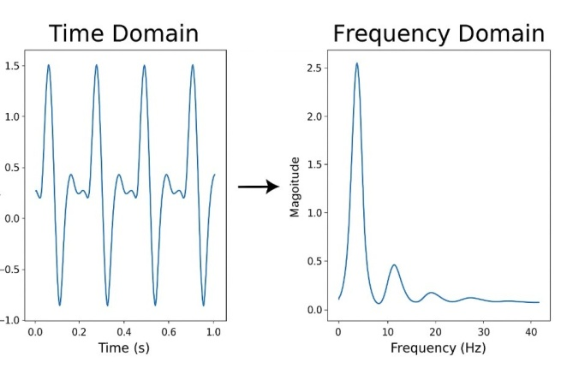

Figure 4.1: FFT

4.1.2 Feature Extraction

The decomposition of ECG signals through Fast Fourier Transform (FFT) together with wavelet decomposition produces separate independent signal components which reveal distinct identity data and medical condition and health status particulars. The examination method establishes the boundary between identity indicators and health condition indicators in all separate components.

The deep learning model accepts ECG signals to generate latent space representations which the system protects by maintaining the safety of personal information. GANs and autoencoders work together in the system to identify which parts of patient information are condition-related and which parts belong to their identity.

4.1.3 Deep Learning Model Design

ECG data processed in this way functions as network input to construct an effective pattern recognition framework for health assessment through either a CNN or RNN neural network structure. The designed model uses TensorFlow or PyTorch software frameworks to execute its development process.

The optimization technique for loss functions maintains important medical data while it eliminates complete patient identification information from modified ECG signals. A shared purpose is to generate ECG data which lacks patient connecting identifiers resulting from the modifications made to the data.

4.1.4 Signal Modification and Reconstruction

The learned latent space representation will operate as the basis to modify ECG signals through the elimination of individual identity features. The transformed restored model will perform data reconstruction of the original signal format after receiving modified data that features concealed identity information.
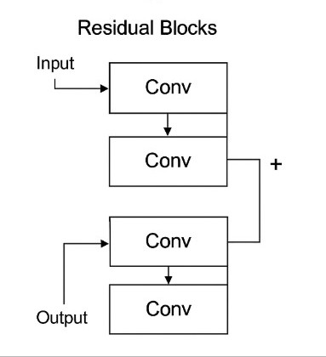

Figure 4.1.1: Converter Block
4.2 Tools and Technologies

4.2.1 Software Development Tools

The choice of Python as programming language starts all tasks because it functions as the key tool for data processing and model development along with signal reconstruction.

The project must use deep learning toolkits TensorFlow along with Keras and PyTorch to create deep learning models for training purposes.

The project requires signal processing algorithms supported through the integration of NumPy and SciPy software packages.

The success rates in identity and condition data recovery from modified signals are determined through the evaluation capabilities of scikit-learn provided to machine learning models.

4.2.2 Tech Stack
The medical recordings will undergo secure storage through AWS S3 together with Google Cloud Storage as cloud storage solutions.
A database system utilizing SQL/NoSQL processes patient demographic along with health condition data through metadata management and organization functions.
Version Control: Git for version control and collaboration within the team.

4.2.3 Development Environment
Teacher development takes place within Jupyter Notebooks to create machine learning models until developers switch to implement their work through VS Code or PyCharm.
Standardised environments for deployment operations are created using Docker containers during the deployment process.

4.3 Evaluation Plan

4.3.1 Model Accuracy Evaluation
This research employs a machine learning classifier either as support vector machine or random forest to figure out identity data coming from original ECG recordings and altered ECG data. The performance evaluation of the modification technique depends on measuring the drop in classifier performance levels.
The model will train an independent system to detect health conditions from ECG signal information. The assessment checks to maintain health information while shielded from identity-related information.

4.3.2 Metrics for Evaluation
Accuracy: A 5-fold cross-validation method will determine the accuracy and F1-score of the classifier before and after identity removal occurs.
The accuracy reduction rates will confirm how well ECG data identity suppression techniques work.
The quality assessment for reconstructed ECG signals through Signal-to-Noise Ratio (SNR) evaluation will verify medical data retention.
Differential privacy together with k-anonymity approaches will verify privacy protection by preventing any risks of patient re-identification. 4.4 Data Management Plan

4.4.1 Data Collection and Storage
Privacy compliance will be achieved through the process of de-identification and collection from open-source ECG databases.
Encrypted formats will receive the stored ECG signals according to privacy standards which implement AES-256 encryption rules.

4.4.2 Data Processing
Prior to model entry the raw ECG data receives local processing at the first step. The models conduct operations on anonymous signals which protect patient-related data from exposure.
The data along with separate subsets will split into validation assets and cross-validation data partitions to check both overfitting problems and model generalization capabilities.

4.4.3 Privacy Protection
All personal identifying information will receive complete removal before processing occurs on collected datasets during the preprocessing step. A study will take place to evaluate differential privacy techniques alongside other data masking methods that will improve data protection before model training begins. We demonstrate our method with previously preprocessed online data which we use as our proof of concept.

4.5 Ethical Considerations

4.5.1 Data Security
Data encryption shields sensitive information during storage periods on the system and network transmission times. Every piece of information in this system requires proper authorization before use because encryption rests upon all data.
Qualified staff will receive access privileges to the implemented system and their activities will be recorded through audit logs.

4.5.2 Privacy Concerns
Personal data processing during this project needs to satisfy requirements of both the ‘Australian Privacy Principles’ (APP) and the ‘General Data Protection Regulation’ (GDPR).
A documented procedure for acquiring consent after informing patients will become operational for accessing genuine ECG data.

4.5.3 Non-maleficence
The application function will be safe for ECG data by avoiding any possible harm during usage. Patient privacy protection requires the process to retain medical records that physicians need to diagnose conditions while avoiding damage to identity verification systems.

4.5.4 Bias in Data
The team follows an active approach that requires model development data to integrate components from diverse demographics for minimizing biased and unfair prediction results.
The research methodology enables project developers to establish a robust privacy-protected ECG signal transformation solution that improves data security practices for healthcare.

5. Project Management

5.1 Timeline
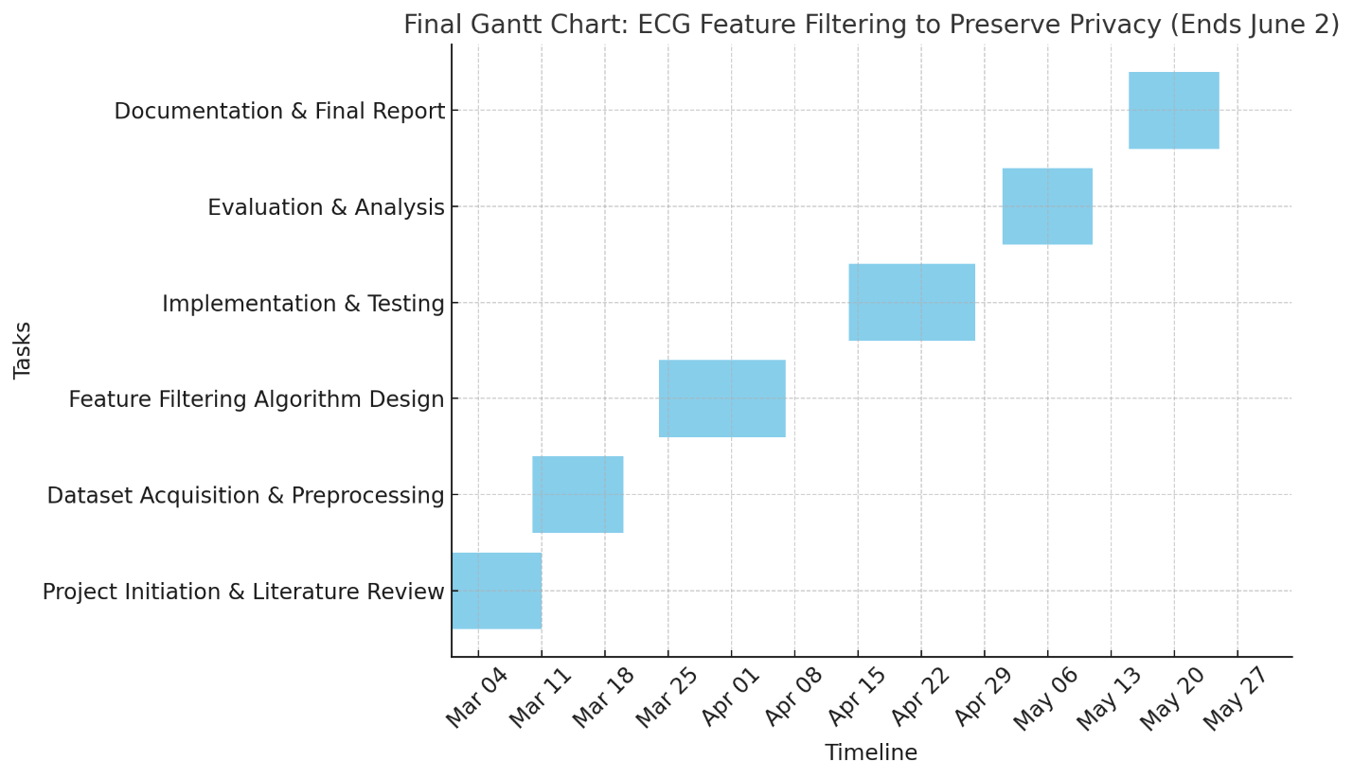

5.2 Milestones
Milestone | Expected Completion | Deliverable
Project plan finalized | 9th march | Project Charter & Scope Definition
Literature Review Completed | 30th march | Summary of Sources & Gaps Identified
Methodology and Data Acquired | 13th April | Dataset, Instruments, Ethics Approved
Initial Data Analysis Completed | 27th April | Preliminary Results & Interpretation
Draft Report Submitted | 11th May | Full Draft of Project
Final Report Submission | 2nd June | Polished Final Document and Code

5.3 Risk Management Plan
Risk | Impact | Likelihood | Mitigation Strategy
Delay In data collection | High | Medium | Start early; prepare alternate sources
Limited access to research resources | Medium | Medium | Use multiple libraries and online databases
Technical issues | High | Low | Regular backups and cloud storage
Team member unavailability | Medium | Medium | Have overlapping task coverage and flexible deadlines
Incomplete analysis due to time constraints | High | Medium | Buffer time added in schedule; early-stage analysis prep

5.4 Task and team Responsibilities

Task | Responsible Members | Timeline
Project Planning & Proposal writing | Ruly, Team Lead | Week 1-2
Literature Review | Anshul, Urva | Week 3-5
Methodology Design & Data Collection | Krina, Nirali | Week 6-7
Data Analysis | Ruly, Nirali | Week 8-9
Draft Report Writing | Urva, Anshul | Week 10-11
Final Report Editing & Submission | Anshul, Krina, Ruly, Qifeng Bi, Urva | Week 12-14

6. References
Agrafioti, F., D. Hatzinakos, and A. K. Anderson. 2012. "ECG Pattern Analysis for Emotion Detection." IEEE Transactions on Affective Computing 3 (1): 102-115. https://doi.org/10.1109/t-affc.2011.28.
Department of Health and Aged Care. 2025. My Health Records Act 2012.https://www.legislation.gov.au/C2012A00063/latest/downloads.
ECG Interpretation. 2008. Lippincott Manual of Nursing Practice Series. Philadelphia: Lippincott Williams & Wilkins.
Hong, Shenda, Can Wang, and Zhaoji Fu. 2020. “Cardioid: Learning to Identification from Electrocardiogram Data.” Neurocomputing 412: 11–18. https://doi.org/10.1016/j.neucom.2020.05.099.
Huang, Pei, Linke Guo, Ming Li, and Yuguang Fang. 2019. “Practical Privacy-Preserving ECG-Based Authentication for IoT-Based Healthcare.” IEEE Internet of Things Journal 6 (5): 9200–9210.
Ibaida, Ayman, and Ibrahim Khalil. 2013. “Wavelet-Based ECG Steganography for Protecting Patient Confidential Information in Point-of-Care Systems.” IEEE Transactions on Biomedical Engineering 60 (12): 3322–3330.
Ingale, Mohit, Renato Cordeiro, Siddartha Thentu, Younghee Park, and Nima Karimian. 2020. “ECG Biometric Authentication: A Comparative Analysis.” IEEE Access 8: 117853–117866.
Liu, Shiya, Yue Yao, Chaoyue Xing, and Tom Gedeon. 2020. “Disguising Personal Identity Information in EEG Signals.” In Neural Information Processing: 27th International Conference, ICONIP 2020, Bangkok, Thailand, November 18–22, 2020, Proceedings, Part V, 27:87–95. Springer International Publishing.OVIC. 2019. Biometrics and Privacy – Issues and Challenges. https://ovic.vic.gov.au/privacy/resources-for-organisations/biometrics-and-privacy-issues-and-challenges/.
Meltzer, David, and David Luengo. 2025. "ECG-Based Biometric Recognition: A Survey of Methods and Databases." Sensors (Basel, Switzerland) 25 (6): 1864.
Odinaka, Ikenna, Po-Hsiang Lai, Alan D Kaplan, Joseph A O'Sullivan, Erik J Sirevaag, and John W Rohrbaugh. 2012. "ECG biometric recognition: A comparative analysis." IEEE Transactions on Information Forensics and Security 7 (6): 1812-1824.
Pereira, Teresa MC, Raquel C Conceição, Vitor Sencadas, and Raquel Sebastião. 2023. "Biometric recognition: A systematic review on electrocardiogram data acquisition methods." Sensors 23 (3): 1507.
Wang, Yongjin, Foteini Agrafioti, Dimitrios Hatzinakos, and Konstantinos N. Plataniotis. 2007. "Analysis of Human Electrocardiogram for Biometric Recognition." EURASIP Journal on Advances in Signal Processing 2008 (1). https://doi.org/10.1155/2008/148658.
Yang, Wencheng, and Song Wang. 2021. “A Privacy-Preserving ECG-Based Authentication System for Securing Wireless Body Sensor Networks.” IEEE Internet of Things Journal 9 (8): 6148–6158.
7. Appendices

